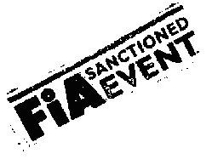  FIA Central Europe Zone Autocross Championship
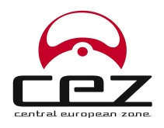
Autocross
Túrkeve
31.07.2016

Entry form
golyo@motorsport.hu before 27/07/2016
Start Nr.: |  | Division: |  | Category:

 | Competitor: | Driver:
Name:
Address (with ZIP code):
Phone:
E-mail:
Licenc Nr:
Representative of the competitor: |  | Paddock:

The Car

Make/Model: |  | Chassis Nr.: |  | FIA Homologation Nr.:

ccm:  Turbo: yes / no |  | Division: |  | 4wd / 2wd

The signer recognizes the rules of the Hungarian Autocross Standard Regulations and Supplementary Regulations and undertakes to strictly observe them. By signing the entry form the driver consent to be implemented during the race, alcohol and drug test.He confirms that the statements made on this entry form are correct and that the entered car conforms with the current conditions of the Int. Sporting Code, Appendix J of the FIA.

Date: | Signature competitor: | Signature driver:
Entry Hungarian Championship 30/07/2016 YES – NO entry form -

